**CRYPTOCURRENCY PRICE PREDICTION**

Ragul TN1, Karthikeyan I1, Vaidyanathan K1,and Dr.GRHemalakshmi2

1Department of Computer Science and Engineering, National Engineering College,

Kovilpatti,Tamil Nadu.

2Assistant Professor (Senior Grade), Department of Computer Science, National Engineering

College, Kovilpatti, Tamil Nadu, India.

**Abstract**: Cryptocurrencies are a form of digital currency where all transactions are conducted electronically. Unlike fiat currency, which is centralized and requires third-party intervention, virtual currency users can access services without intermediaries. This means it exists only in digital form and does not have physical notes or coins. Our study aims to develop efficient prediction models using deep learning techniques, precisely long short-term memory (LSTM) and gated recurrent unit (GRU) to handle Bitcoin's price volatility and achieve high accuracy. We will compare the effectiveness of these two-time series deep learning models and demonstrate their ability to forecast Bitcoin prices.

**Keywords**: *LSTM-Long Short Term Memory, GRU-Gated Recurrent Unit*.

# **1.** **Introduction**

Bitcoin has multiplied since 2017, and its price has frequently increased, attracting many investors. Its popularity has reached such a level that, in addition to many private companies, a country has recently announced its acceptance as a payment method.

Not to mention that central bank researchers have been analyzing and discussing it since at least 2014.

The most important factors that differentiate Bitcoin from other types are. Currency is characterized by its decentralization. That said, unlike other currencies, bitcoin transactions are not subject to any government processing and control. Its money supply grows over time, albeit non-linear, through a rewarding " mining " process. Computers participate in solving mathematical equations by brute force and are rewarded with bitcoins. The classic law of supply and demand determines the exchange rate of Bitcoin's price against other currencies.

Similar to any other financial process, bitcoin prices can be predicted by artificial neural network methods. While implementing artificial neural network methods to predict other financial processes such as (e.g., stock prices) is long, and due to their novel nature, there is not much literature on the cryptocurrency price prediction. Nevertheless, in recent years, many researchers have attempted to create hybrid artificial neural network models to predict prices and price fluctuations in cryptocurrency prices, primarily focusing on Bitcoin.

A severe limitation of RNNs is the inability to capture long-term dependencies in sequences. One way to handle this situation is to use a long-short-term memory (LSTM) variant of RNN.

The cryptocurrency market differs from the traditional stock market because it has several new features.

It is necessary to apply new technologies suitable for the cryptocurrency market for forecasting. There is less research on cryptocurrency price predictions than on the stock market.

This algorithm works great for time series data such as time series, voice, text, financial data, audio, video, weather, etc. RNNs can understand sequences and their context better than other algorithms. In RNNs, information follows a cycle.

When making a decision, it considers the current input and what it has learned from previously received inputs.

# 

# **2. Related Work**

[1] Sina E. Charandabi, Kamyar Kamyar(2021) -The purpose of the study is to examine whether the application of deep learning-based dual-stage Partial Least Square-Structural Equation Modeling (PLS-SEM) & Artificial Neural Network (ANN) analysis enables better in-depth research results as compared to single-step PLS-SEM approach and to excavate factors which can predict behavioural intention to adopt cryptocurrency.

[2]Ahmed M. Khedr, Ifra Arif, Pravija Raj P V(2021) – Traditional statistical methods require a lot of statistical assumptions that could be unrealistic, leaving machine learning as the best technology in this field. This article comprehensively summarises the previous studies in cryptocurrency price prediction from 2010 to 2020. The discussion presented in this article will help researchers fill the gap in existing studies and gain more insight.

[3]Edwin, Lipo Wang (2017) - Described the features of Bitcoin and the following day's change in the price of Bitcoin using an Artificial Neural Network ensemble. The features of Bitcoin and the following day change in the price of Bitcoin using an Artificial Neural Network ensemble approach called Genetic Algorithm-based Selective Neural Network Ensemble, constructed using Multi-Layered Perceptron as the base model for each of the neural network in the ensemble.

[4] Yeray Mezquita, Ana Belén Gil-González, Javier Prieto, Juan Manuel Corchado (2021)-This paper proposes a platform based on blockchain technology and the multi-agent system paradigm to allow for the creation of an automated peer-to-peer electricity market in micro-grids. Using a permissioned blockchain network has multiple benefits, reducing transaction costs and enabling micro-transactions.

[5] Lloyd Kasal, Mihir Shetty, Tanmay Nayak, Ramanath Pai, and Shilpa B(2022) proposed that numerous neural networks may be utilized to analyze cryptocurrency values. The most successful of them all has been determined to be LSTM. The key factors used are available price, close price, high price, low price, volume, and market cap with the interdependencies amid some cryptocurrencies, thus centres on evaluating vital features that influence the trade's unpredictability by applying the model to increase the effectiveness of this process.

[6]Ahmed M. Khedr Ifra Arif Pravija Raj P V Magdi El-Bannany (2021)- proposed that traditional statistical methods, although simple to implement and interpret, require a lot of statistical assumptions. This article comprehensively summarises the previous studies in cryptocurrency price prediction from 2010 to 2020. The discussion presented in this article will help researchers fill the gap in existing studies and gain more insight.

[7]Caporale, Guglielmo Maria Plastun, Alex (2018)-A trading robot approach is then used to establish whether these statistical anomalies can be exploited to generate profits. The results suggest that a strategy based on counter-movements after overreactions is not profitable, whilst one based on inertia appears profitable but produces outcomes not statistically different from the random ones.

[8]Al-Yahyaee KH, Mensi W(2020) -Multifractality, long-memory process, and efficiency hypothesis of six significant

cryptocurrencies using the time-rolling MF-DFA approach. The causality between cryptocurrencies and economic factors is undirected. Interestingly, our findings show that cryptocurrencies are insignificant correlations with economic factors. The result implies that cryptocurrencies can not be assumed as financial assets to hedge systematic risks from economic factors.

[9]Magdi El-Bannany, Saadat M. Alhashmi, Meenu Sreedharan(2016) - Cryptocurrency price prediction using traditional statistical and machine-learning techniques, this type of model approach called Genetic Algorithm based Selective Neural Network Ensemble.

[10]Ujan Mukhopadhyay; Anthony Skjellum; Oluwakemi; Hambolu; Jon Oakley; Richard Brooks(2022) proposed that Cryptocurrencies require robust and secure mining algorithms. In this paper, we survey and compare and contrast current mining techniques used by major Cryptocurrencies. Mining adds records of past transactions to the distributed ledger known as Blockchain, allowing users to reach secure, robust consensus for each transaction. Mining also introduces wealth in the form of new units of currency. Cryptocurrencies lack a central authority to mediate transactions because they were designed as peer-to-peer systems

[11] Carmine Ventre, Michail Basios, Leslie Kanthan, David Martinez-Rego(2022), This survey analyzes the research distribution that characterizes cryptocurrency Research and distribution among properties. This also analyzes datasets, research trends and distribution among research objects (contents/properties) and technologies, concluding with promising cryptocurrency trading opportunities.

[12] Sina E. Charandabi; Kamyar Kamyar (2021), This survey paper aims to present and compare multiple research papers that employed multiple neural networks. Researchers would be allowed to decide the more suitable direction of work to provide more accurate alternatives to the field.

[13] Saeed Alzahrani; Tugrul U. Daim(2019) -Paper suggests that the main factors driving the adoption decision are the acceptance by businesses as a payment method and the fast transfer of funds. This aims at providing an in-depth analysis of the factors influencing the adoption of cryptocurrency as well as the ranking of these influencing factors based on the quantification of the users' judgments.

[14]Pravija Raj, Magdi El-Bannany, Saadat M.Alhashmi, Meenu Sreedharan(2021) –Research in this field uses traditional statistical and machine-learning techniques, making it hard to predict using a statistical approach, such as Bayesian regression, logistic regression, linear regression, support vector machine, artificial neural network, deep learning, and reinforcement learning. No seasonal effects exist in cryptocurrency, making it hard to predict using a statistical approach.

[15] [George S.](https://www.sciencedirect.com/science/article/pii/S037722171930075X#!)Atsalakis(2021) –Fuzzy modelling demonstrating that the closed-loop or feedback control technique can cope with uncertainties associated with the dynamic behaviour of the price of Bitcoin and achieve positive returns. This study proposes a computational intelligence technique that uses a hybrid Neuro-Fuzzy controller, namely PATSOS, to forecast the direction of the change of Bitcoin's daily price.

**3. Methodology**

LSTM (Long Short-Term Memory) is another module provided for RNN. LSTM was developed and promoted by Hochreiter & Schmidhuber (1997) [3]and later by many researchers. Like RNNs, LSTM networks (LSTM networks) are also composed of cyclically coherent modules.

LSTM is an updated version of RNN; the difference is in the relationship between the hidden layers of RNN. The interpretation structure of RNN is shown in Figure 1. The LSTM recurrent neural network also has a similar structure; another difference is the hidden layer memory unit structure. And the unique three-door design effectively solves the gradient problem. LSTM memory structure for hidden layers.

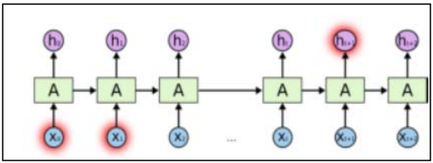

Fig 3.1: LSTM architecture

Some things in the figure show that RNN has flaws. Faults can be seen in the input X0, X1 has a lot of miscellaneous information Xt, Xt+1 so that when 1+1 information needs those related X0, X1 to RNN cannot learn Because the association of information stored in old memory becomes increasingly useless over time as it is overwritten or replaced by new memory, Bengio et al. (1994) [22]. Unlike RNN, LSTM has no drawback in that LSTM can manage memory for each input using memory cells and gate cells. The prediction is the easy part. It involves taking prepared input data (X) and calling one of the Keras prediction methods on the loaded model. The input to make predictions (X) contains only the input sequence data needed to make predictions, not all previous training data. In the case of predicting the next value in a sequence, the input sequence will be 1 sample with a fixed number of time steps and features used. The predictive model calculates future predictions using a new autoregressive scheme called the autoregressive moving pointer model. Initially, AMPM is used to generate input-output pairs, given these input-output pairs and generate future predictions. The next step is to form an optimal portfolio based on these predictions, assuming a normal distribution of stock prices.

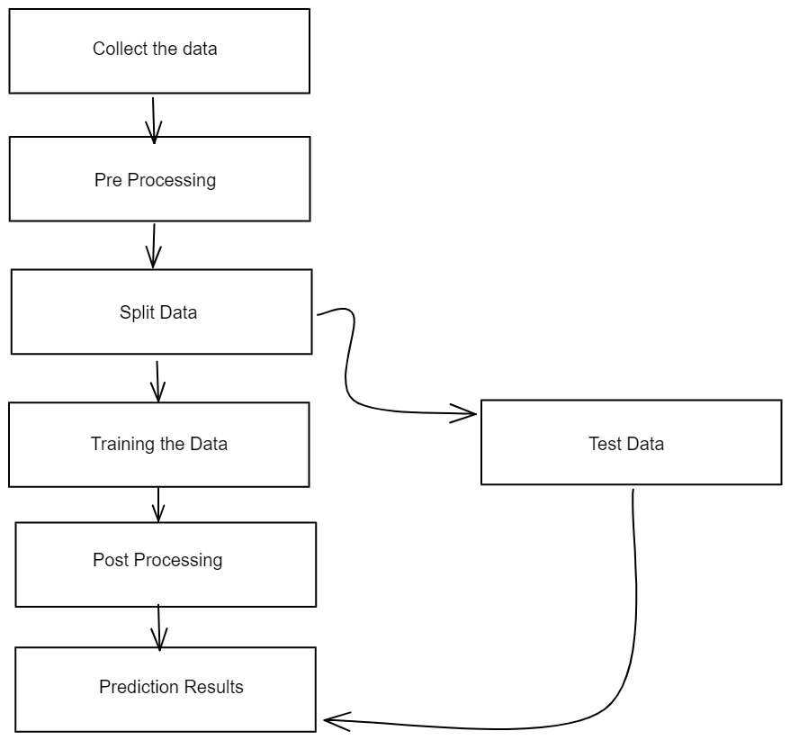

Fig 3.2: Workflow diagram

Statistical methods include the logistic regression model, ARCH model, etc. Artificial intelligence methods include multi-layer perceptrons, convolutional neural networks, naive bayesian networks, backpropagation networks, single-layer LSTMs, support vector machines, recurrent neural networks, etc. Long-short-term memory (LSTM) network.

**3.1.Long Short Term Memory (LSTM)**

LSTM is a unique network structure with three "gate" structures. Three gates are placed in an LSTM cell: entry gate, forget gate, and exit gate. Information entering the LSTM network can be selected according to rules. Only information that conforms to the algorithm will be retained, and the forgetting gate will forget information that does not conform.

LSTMs use a series of "gates" to control how information from a data series enters, stores, and leaves the network. There are three doors in a typical LSTM; the door of oblivion, the door of entry and the door of exit. These gates can be considered filters, and each is its neural network. This network (within the forgetting gate) is trained to have an output close to 0 when a component of the input is considered irrelevant and close to 1 when it is relevant. It is helpful to think of each element of this vector as a filter/sifter, allowing more information to pass as the values ​​approach 1. These output values ​​are then sent and multiplied point by point by the previous state of the cell.

In summary, the forget gate decides which pieces of long-term memory should now be forgotten (with less weight) given the previous hidden state and the new data points in the queue.

**3.2.Recurrent Neural Network (RNN)**

A recurrent neural network (RNN) is an artificial neural network that uses temporal or chronological data. These deep learning algorithms are often used for sequential or temporal problems such as language translation, natural language processing (NLP), speech recognition, and image captioning; they're built into popular apps like Siri, voice search, and Google Translate. Like feedforward and convolutional neural networks (CNNs), recurrent neural networks use training data to learn. They are known for their "memory" as they retrieve information from past entries to influence current entries and exits. Traditional deep neural networks assume that the input and output are independent of each other, while recurrent neural networks' output depends on the sequence's previous elements. Although future events can also be used to determine the output of a given sequence, one-way recurrent neural networks cannot factor these events into their predictions.

**3.3.Convolutional Neural Networks (CNNs)**

CNN is an artificial neural network widely used in image/object recognition and classification. Therefore, deep learning uses CNNs to recognize objects in images. CNNs play an essential role in various tasks/functions such as image processing problems, computer vision tasks such as localization and segmentation, video analysis, identification of obstacles in self-driving cars and speech recognition in natural language processing. Since CNNs play an essential role in these emerging and rapidly developing fields, they are trendy in deep learning.

CNNs are another type of neural network that can reveal critical information in time series and image data. Therefore, it benefits image-related tasks, such as image recognition, object classification, and pattern recognition. To recognize patterns in images, CNNs use the principles of linear algebra, such as matrix multiplication. CNNs can also classify audio and signal data. The architecture of CNN is similar to the connection model of the human brain. Just as the brain is made up of billions of neurons, a CNN has neurons arranged in a specific way. The neural arrangement of the CNN resembles the frontal lobe of the brain, the area responsible for processing visual stimuli. This arrangement ensures that the entire field of view is covered, avoiding traditional neural networks' segmented image processing problems, which must segment input images at lower resolutions. Compared to older networks, CNNs perform better on image and voice or audio signal inputs. A deep-learning CNN consists of the convolutional, pooling, and fully connected (FC) layers. The convolutional layer is the first layer and the FC layer is the last layer. The complexity of CNN increases from convolutional layers to fully connected layers. This increasing complexity allows a CNN to continuously recognize more significant parts of an image and more complex features until it finally recognizes the entire object. Analyze and represent human language.

**3.4.Natural Language Processing (NLP)**

NLP-based systems have enabled a wide range of applications, such as Google's powerful search engine and, more recently, Amazon's voice assistant, Alexa. NLP also helps teach machines the ability to perform complex natural language tasks, such as machine translation and dialogue generation. NLP can recognize and predict disease based on electronic health records and patients' speech. This ability is being studied in health conditions ranging from cardiovascular disease to depression and even schizophrenia. For example, Amazon Comprehend Medical is a service that uses NLP to extract disease states, medications, and treatment outcomes from patient medical records, clinical trial reports, and other electronic health records. Organizations can determine what customers are saying about a service or product by identifying and extracting information from sources such as social media. This sentiment analysis can provide insight into customer choices and the drivers behind their decisions. NLP is also used in the search and selection phase of talent acquisition, identifying the skills of potential recruits and scouting them before they become active in the job market.

**4. Result and Discussion**

LSTM is a complex area of ​​deep learning. LSTMs are often referred to as sophisticated RNNs. Vanilla RNN has no cellular state. They only have hidden states, which serve as the memory of the RNN. At the same time, LSTM has both a cell state and a hidden state, and our proposed model successfully provided Yahoo Finance stock market results to predict Bitcoin. A long-short-term memory (LSTM) network is a recurrent neural network capable of learning sequence dependencies in prediction problems. This is the desired behavior in complex problem areas like machine translation, speech recognition, etc. Our models using time series techniques can provide results that predict prices for the next few days by splitting the data to train and test what we mentioned in the article above.

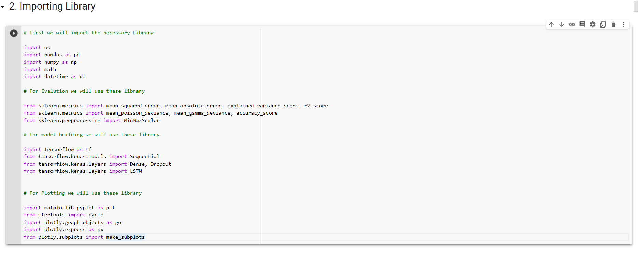

Fig 4.1: Importing Library

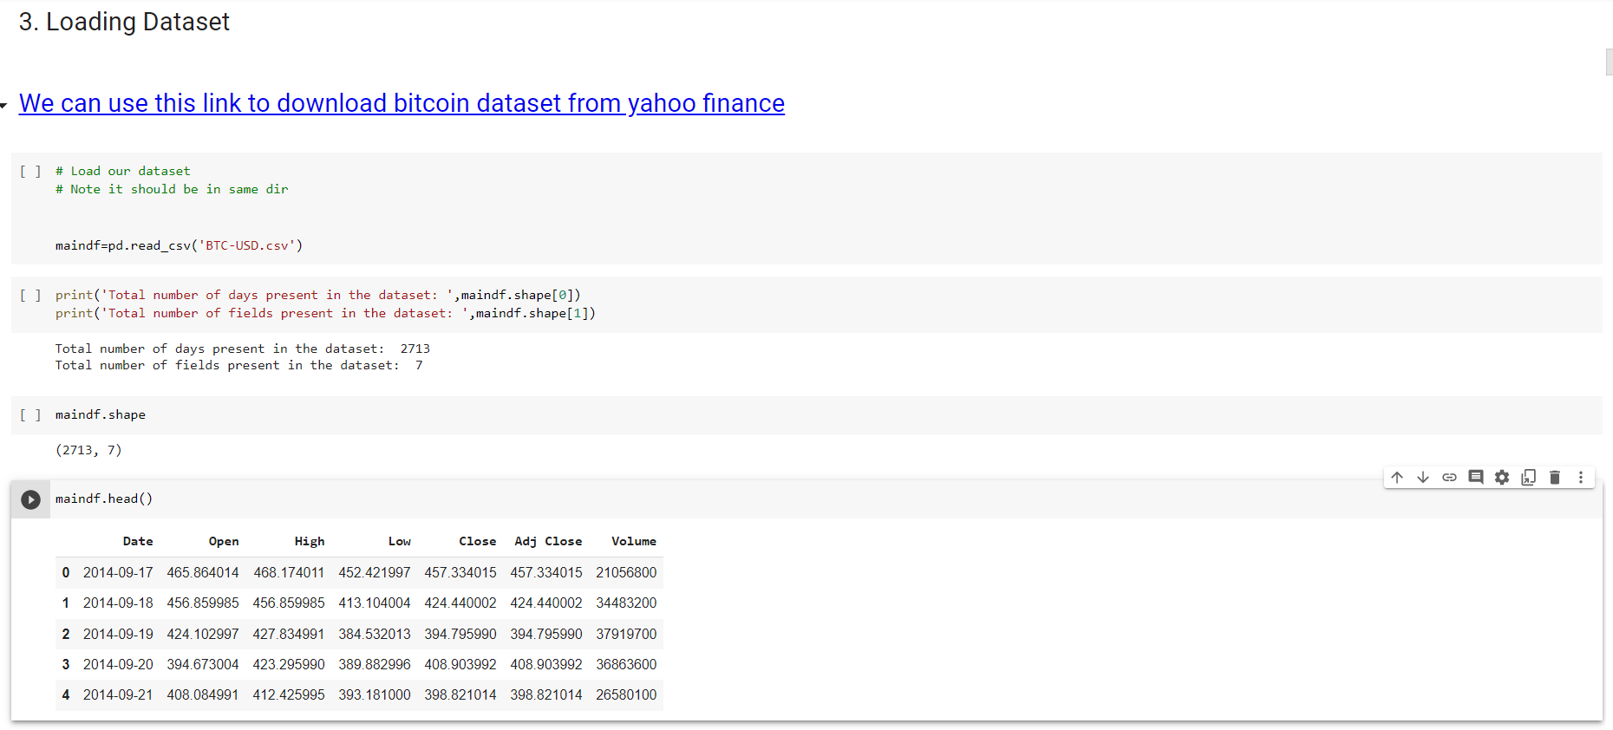

Fig 4.2: Loading Dataset

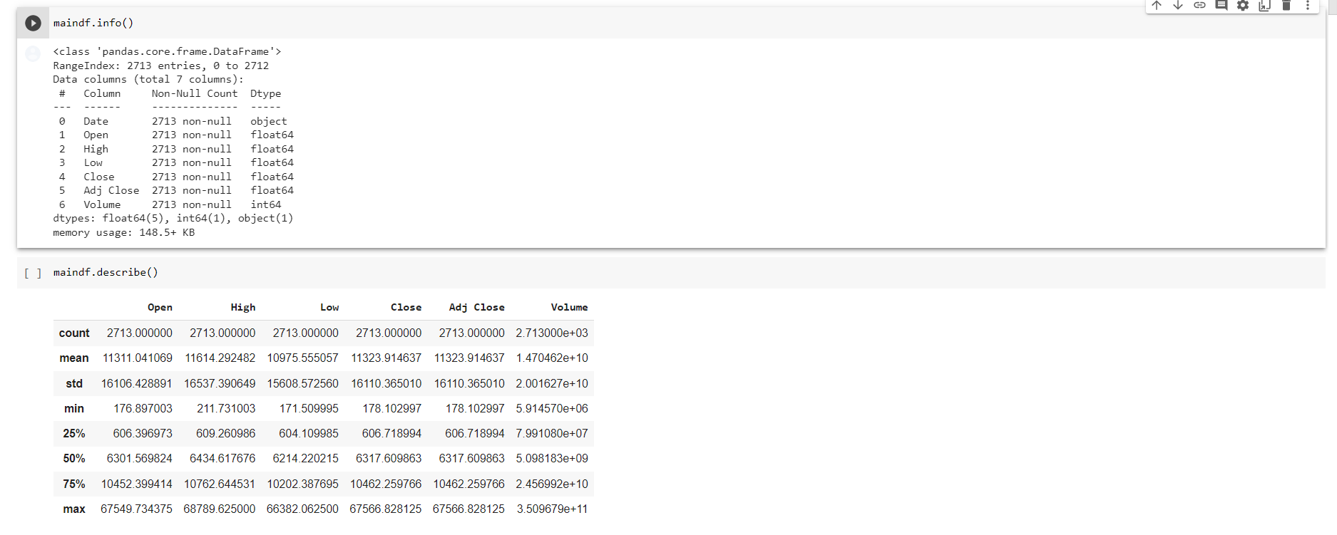

Fig 4.3: Fixing Range for data

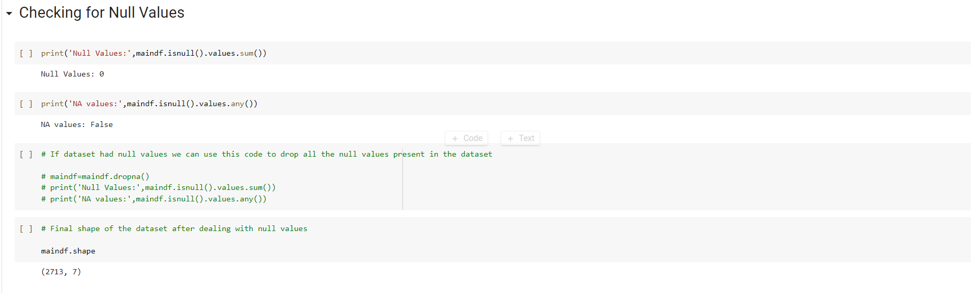

Fig 4.4: Checking for Null values

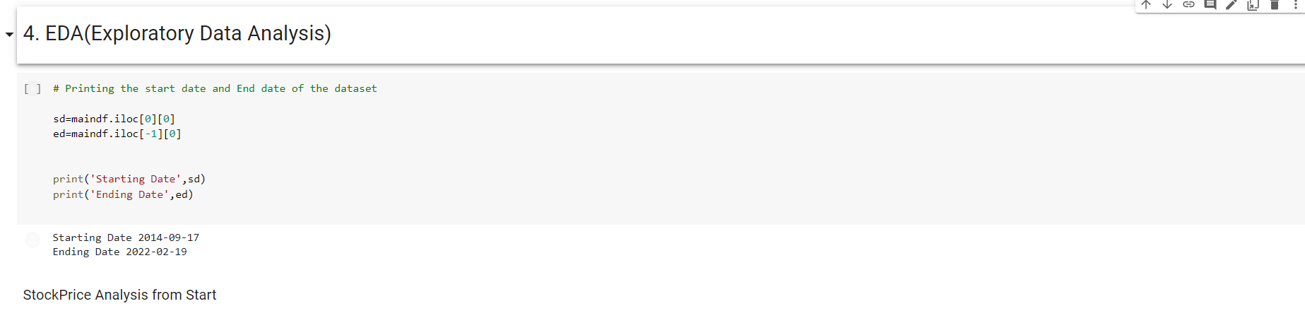

Fig 4.5: Exploratory Data Analysis

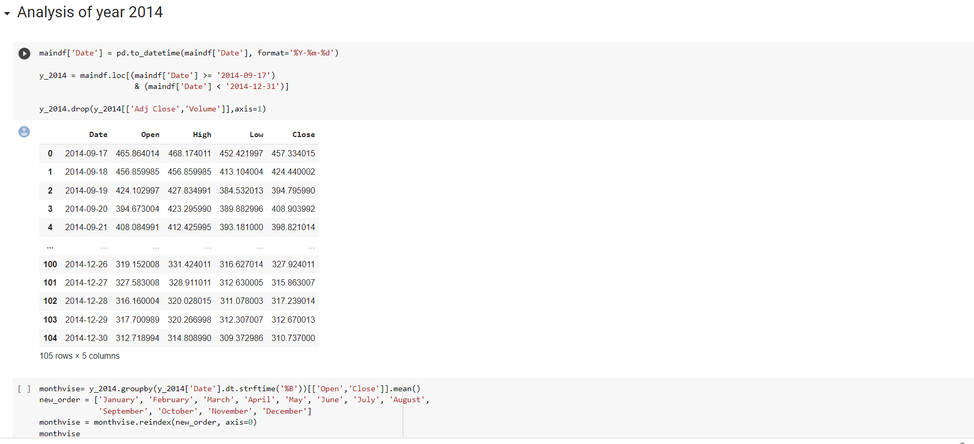

Fig 4.6: Analysis of the year 2014

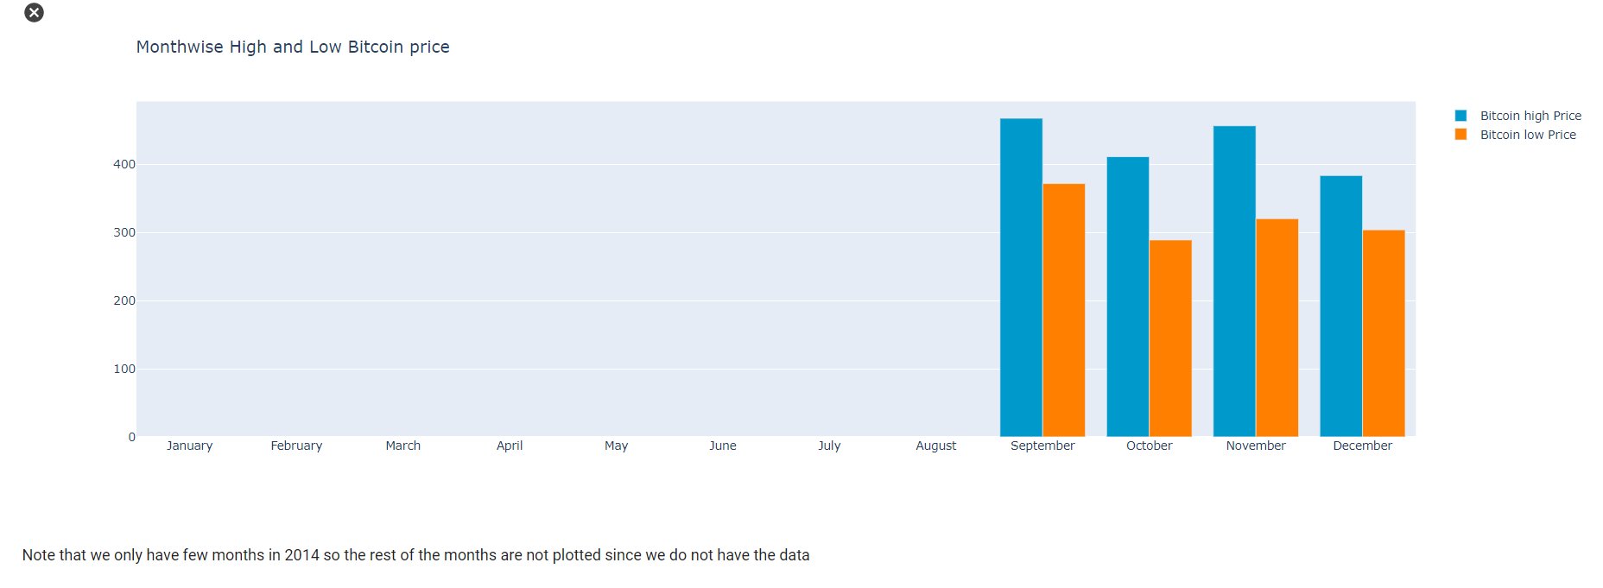

Fig 4.7: The year 2014 Monthwise bitcoin price

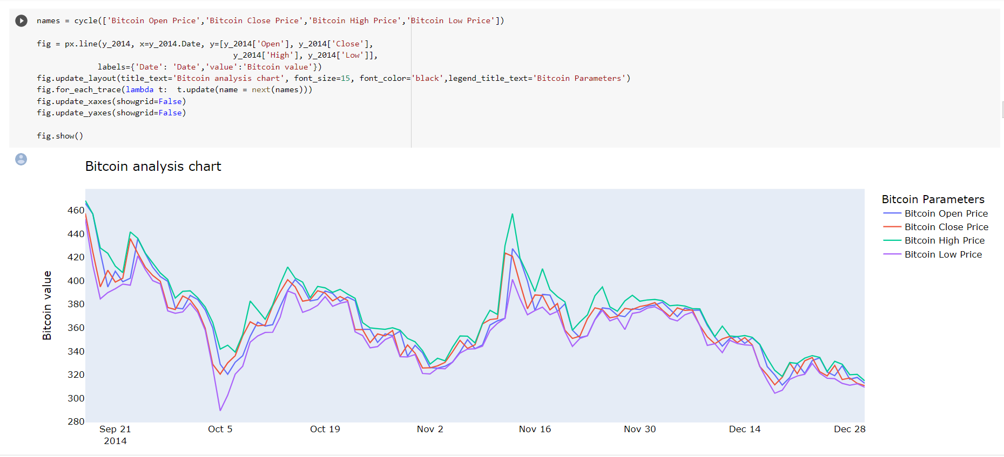

Fig 4.8: Bitcoin analysis chart 2014

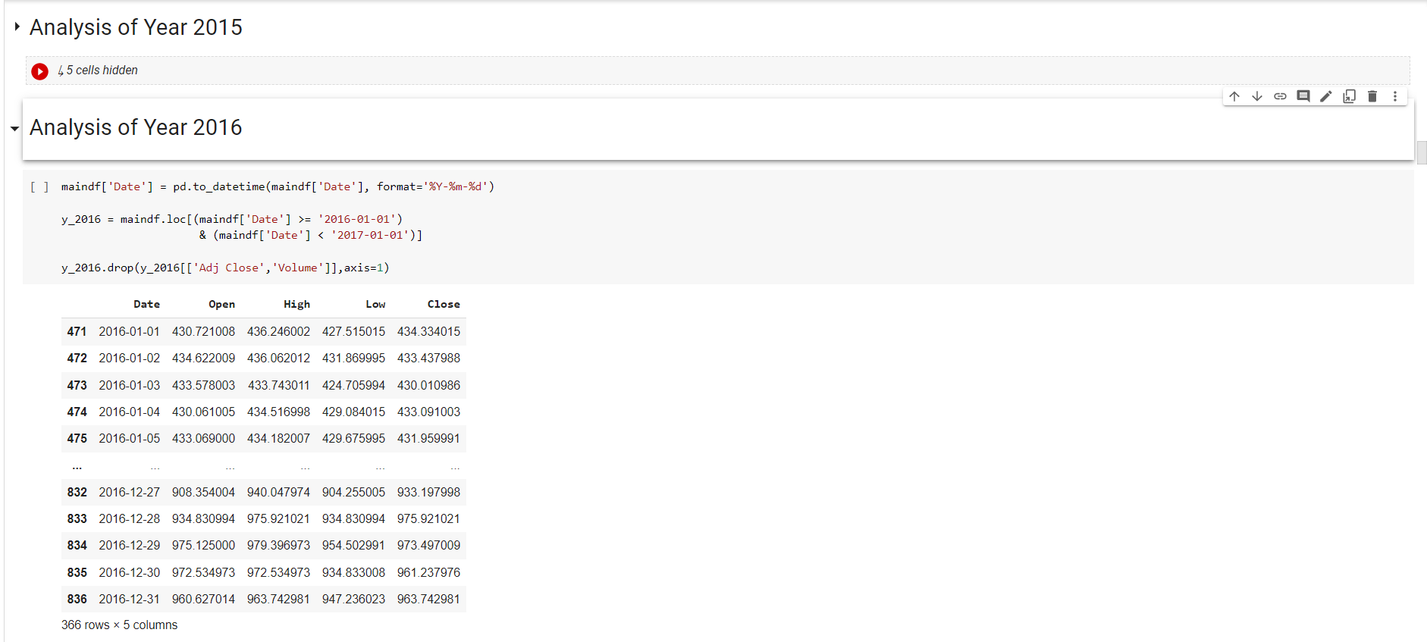

Fig 4.9: Analysis of the year 2015 and 2016

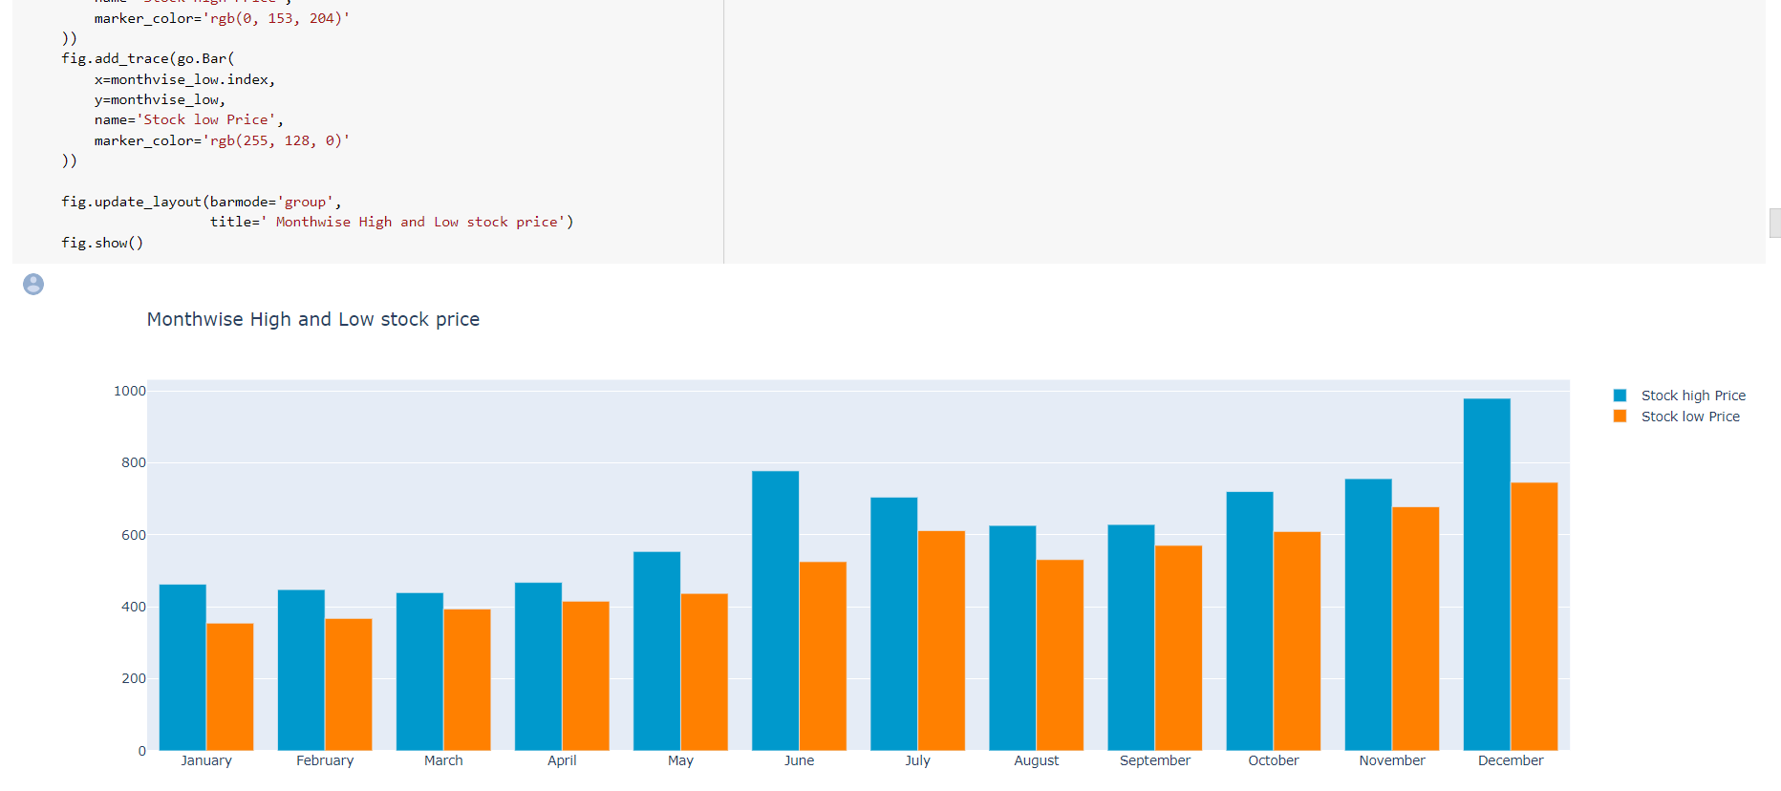

Fig 4.10: The year 2016 month-wise price

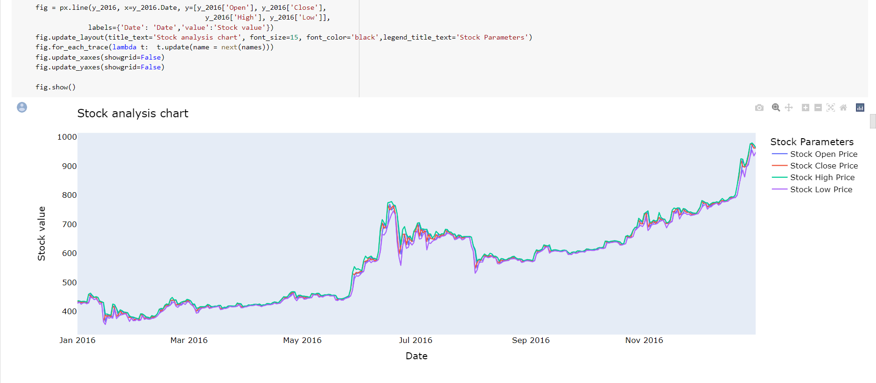

Fig 4.11: Bitcoin analysis chart 2016

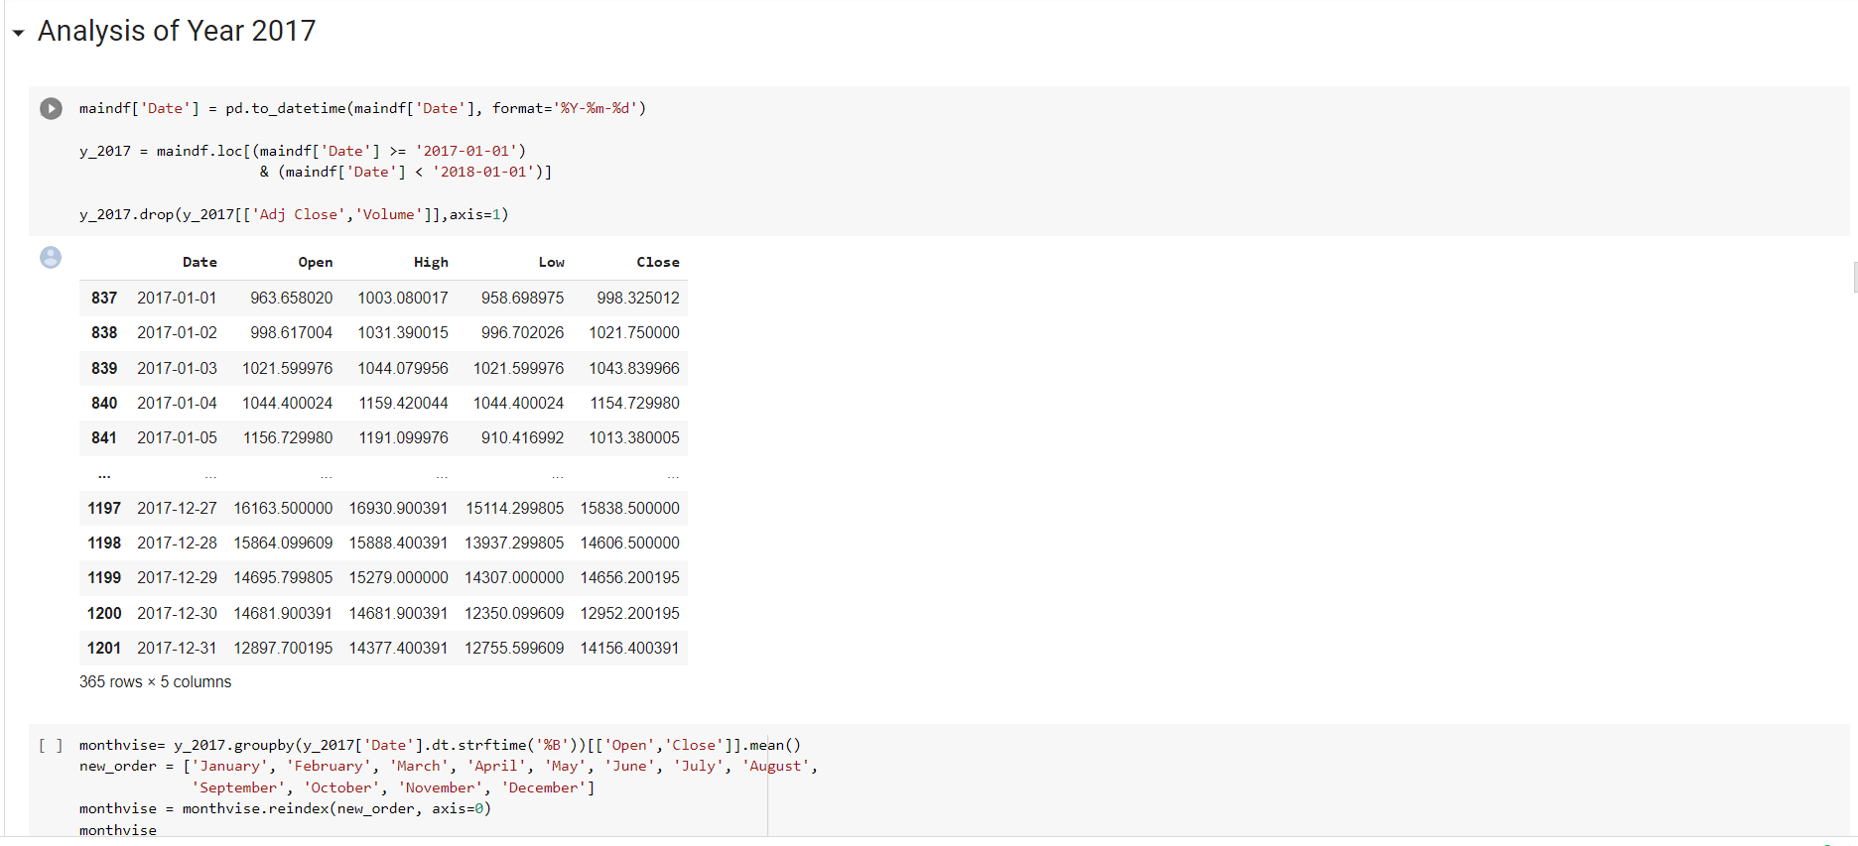

Fig 4.12: Analysis of the year 2017

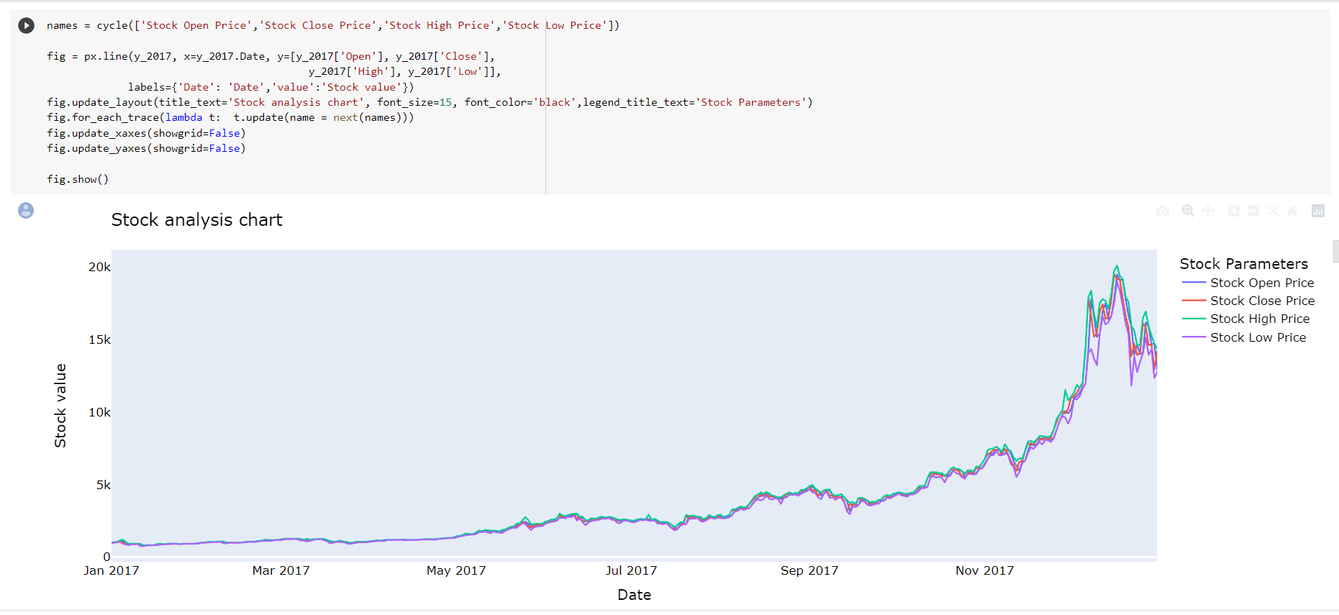

Fig 4.13: Analysis of the year 2017

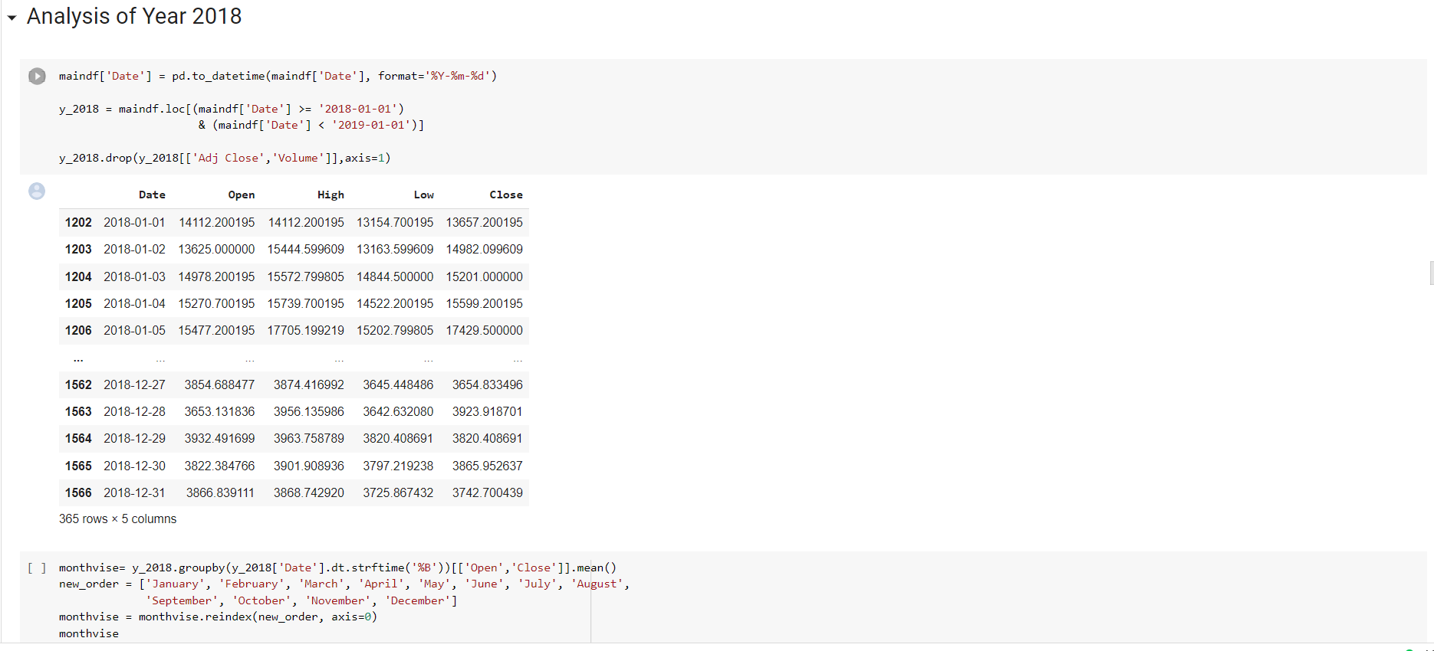

Fig 4.14: Analysis of the year 2018

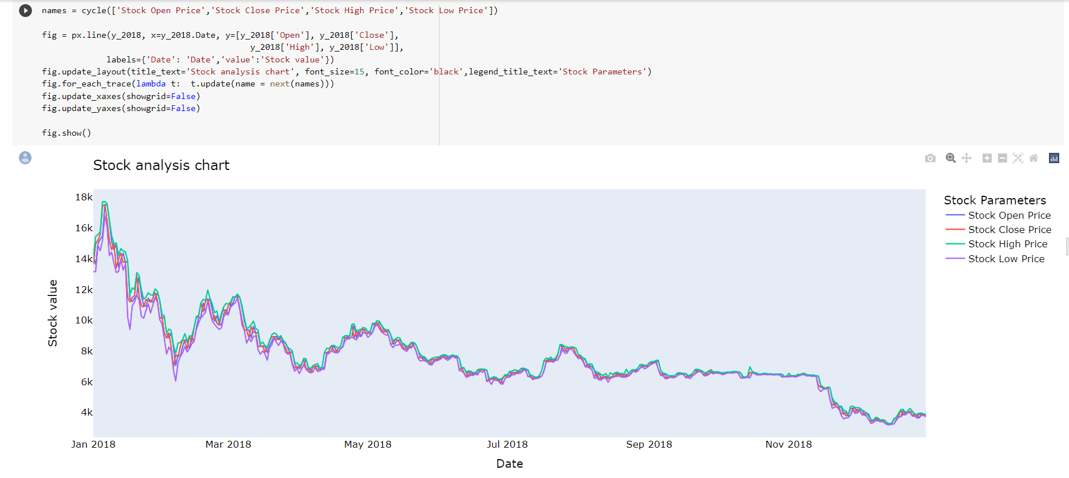

Fig 4.15: Bitcoin analysis chart 2018

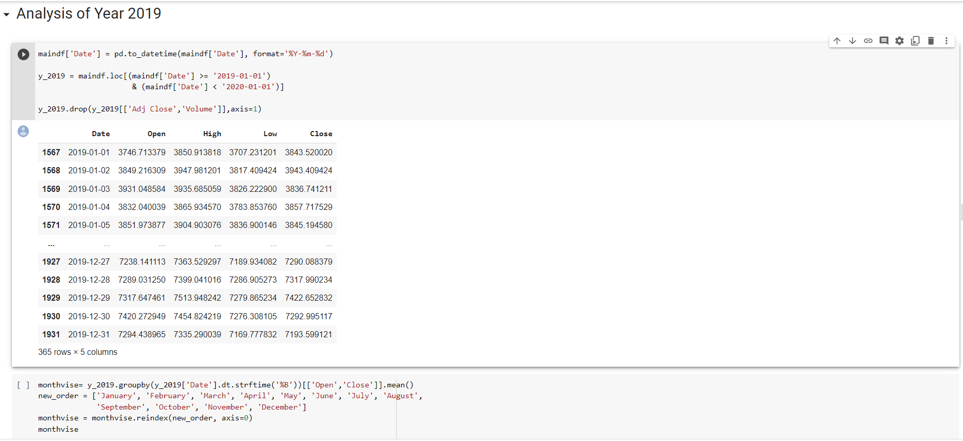

Fig 4.16: Analysis of the year 2019

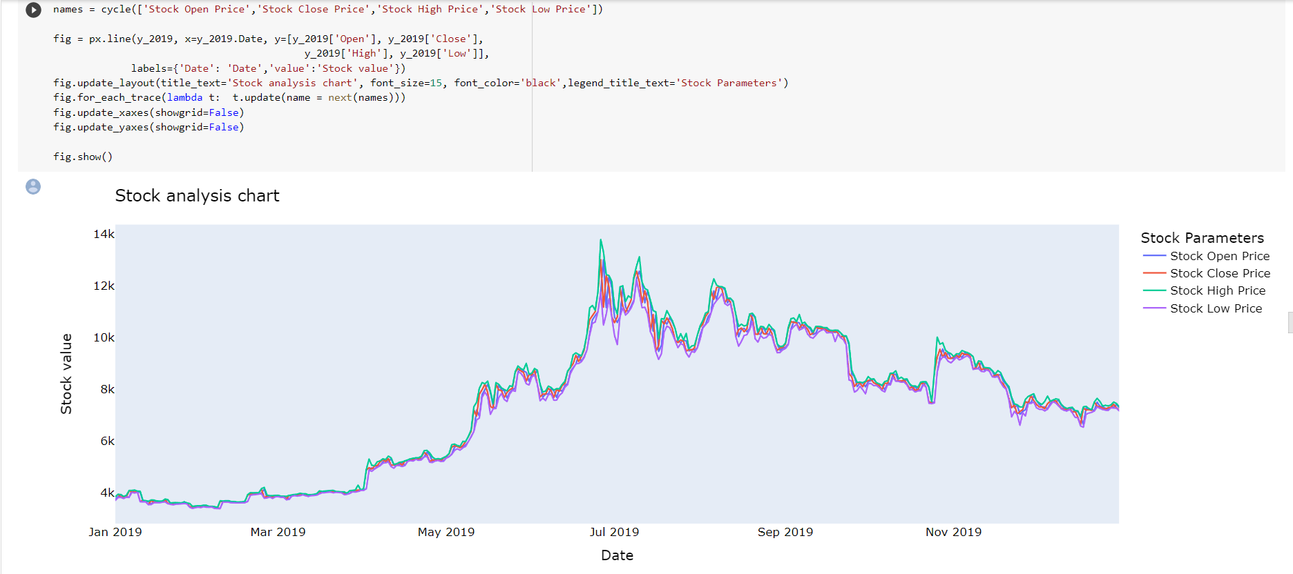

Fig 4.17: Bitcoin analysis chart 2019

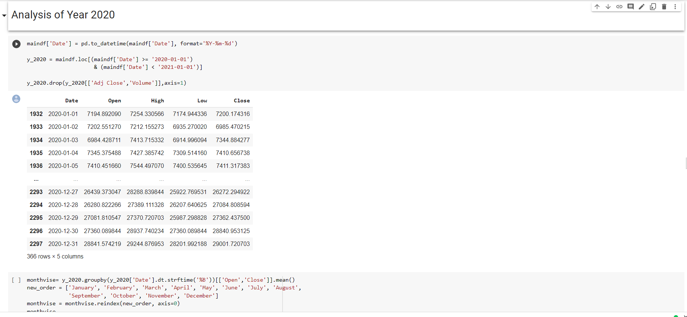

Fig 4.18: Analysis of the year 2020

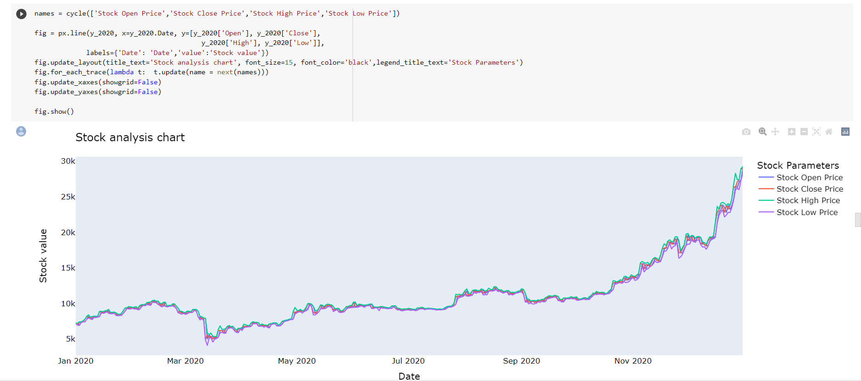

Fig 4.19: Bitcoin analysis chart 2020

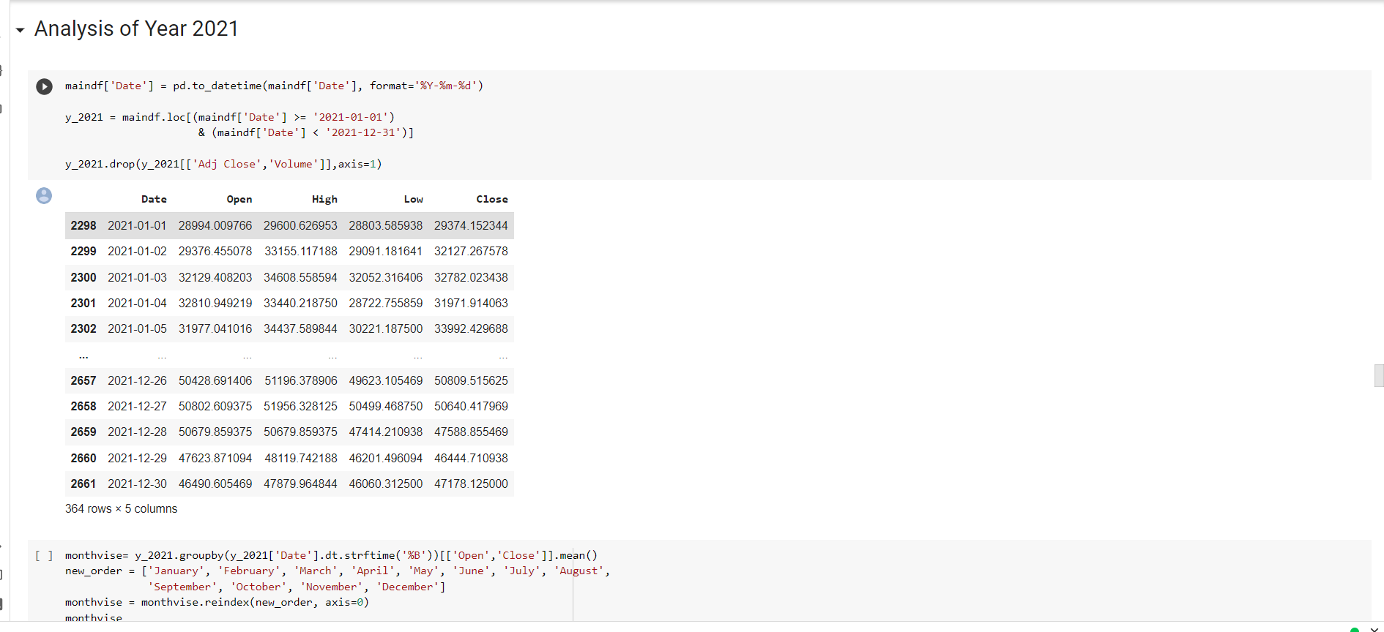

Fig 4.20: Analysis of the year 2021

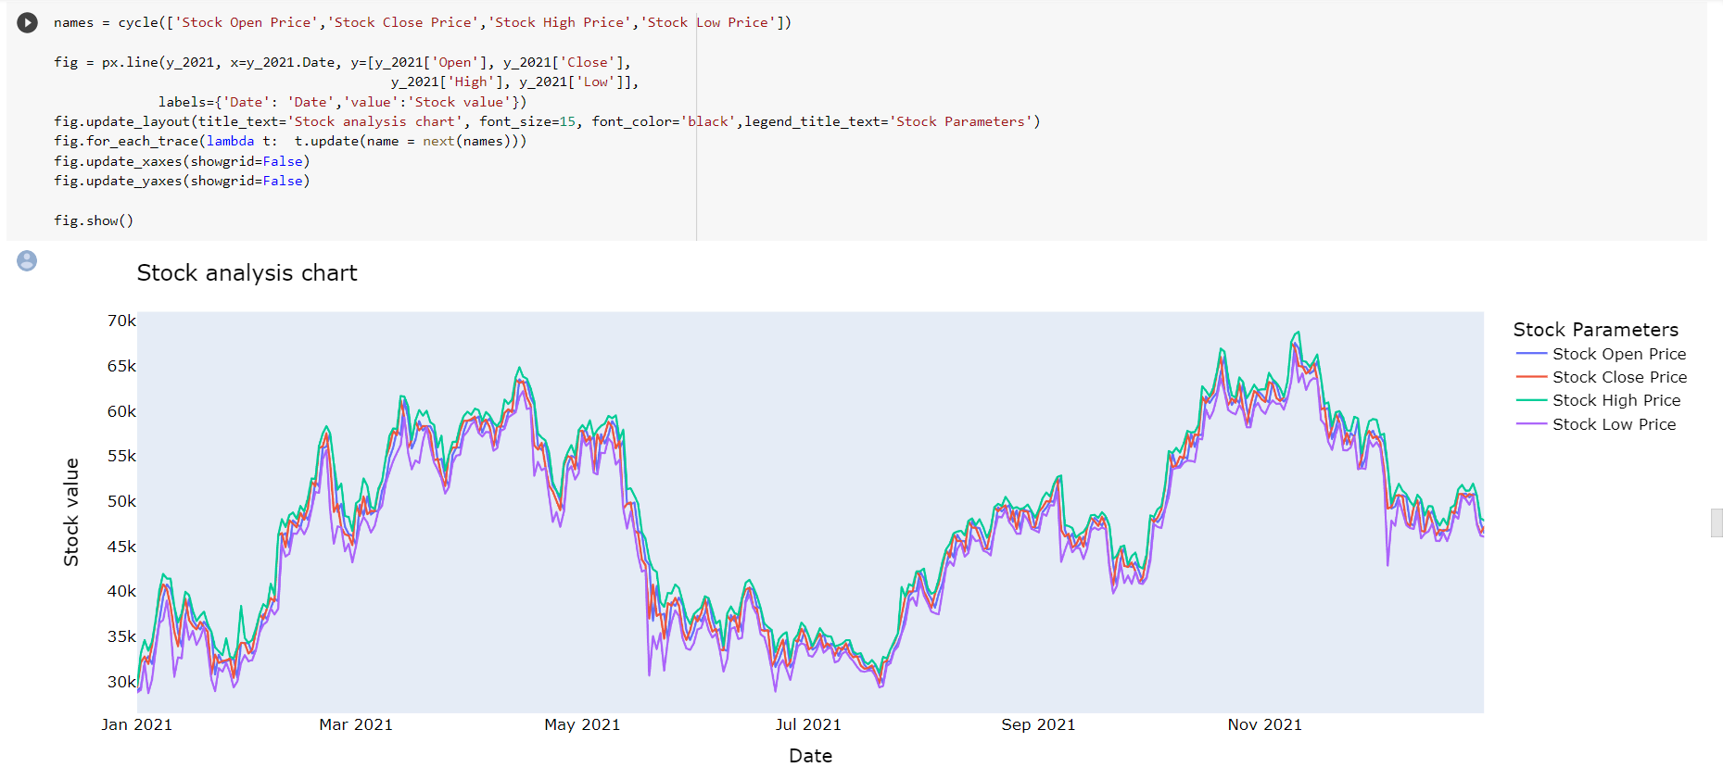

Fig 4.21: Bitcoin analysis chart 2021

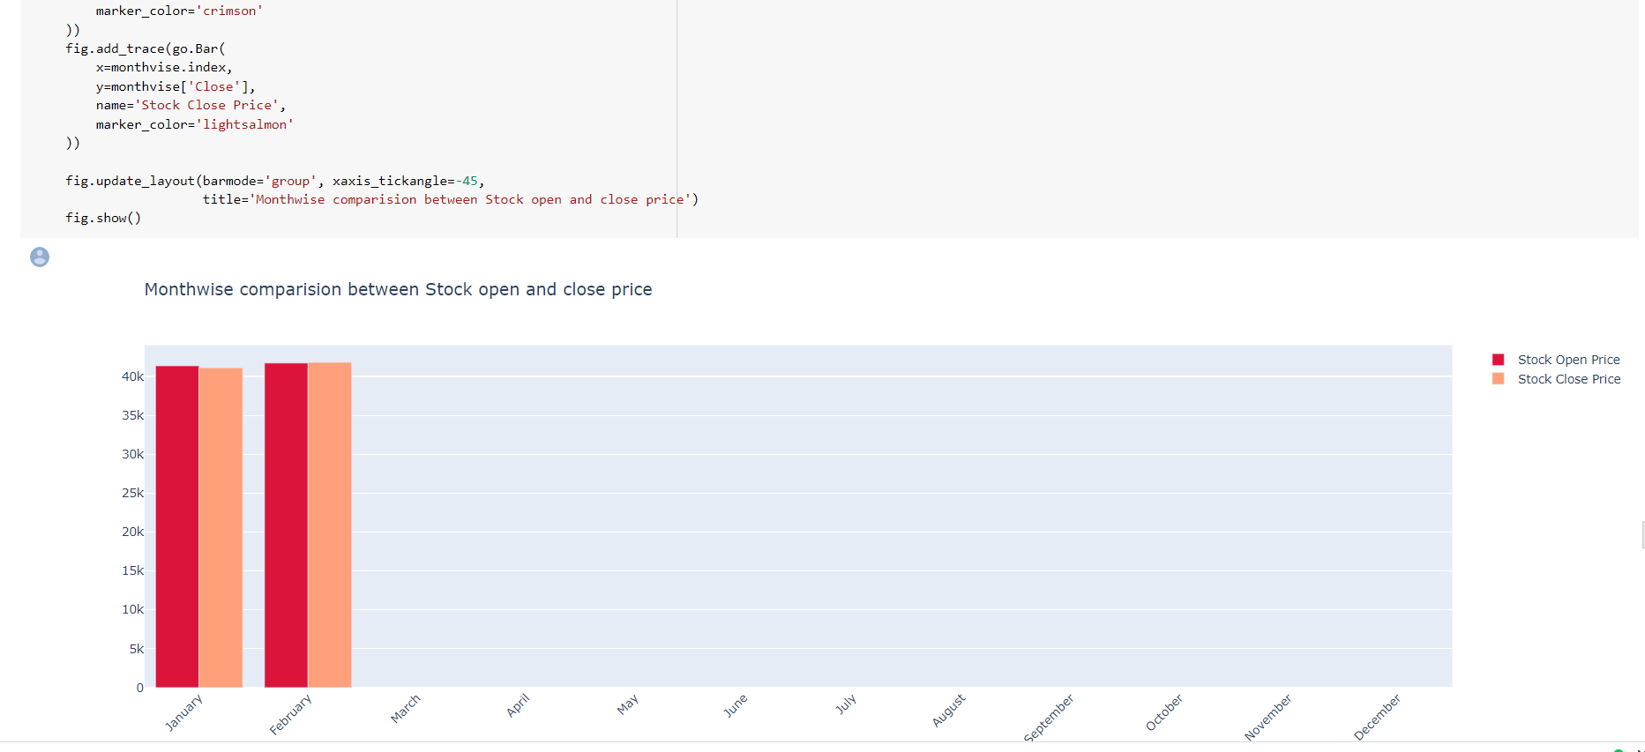

Fig 4.22: Month-wise comparison of stock open and close

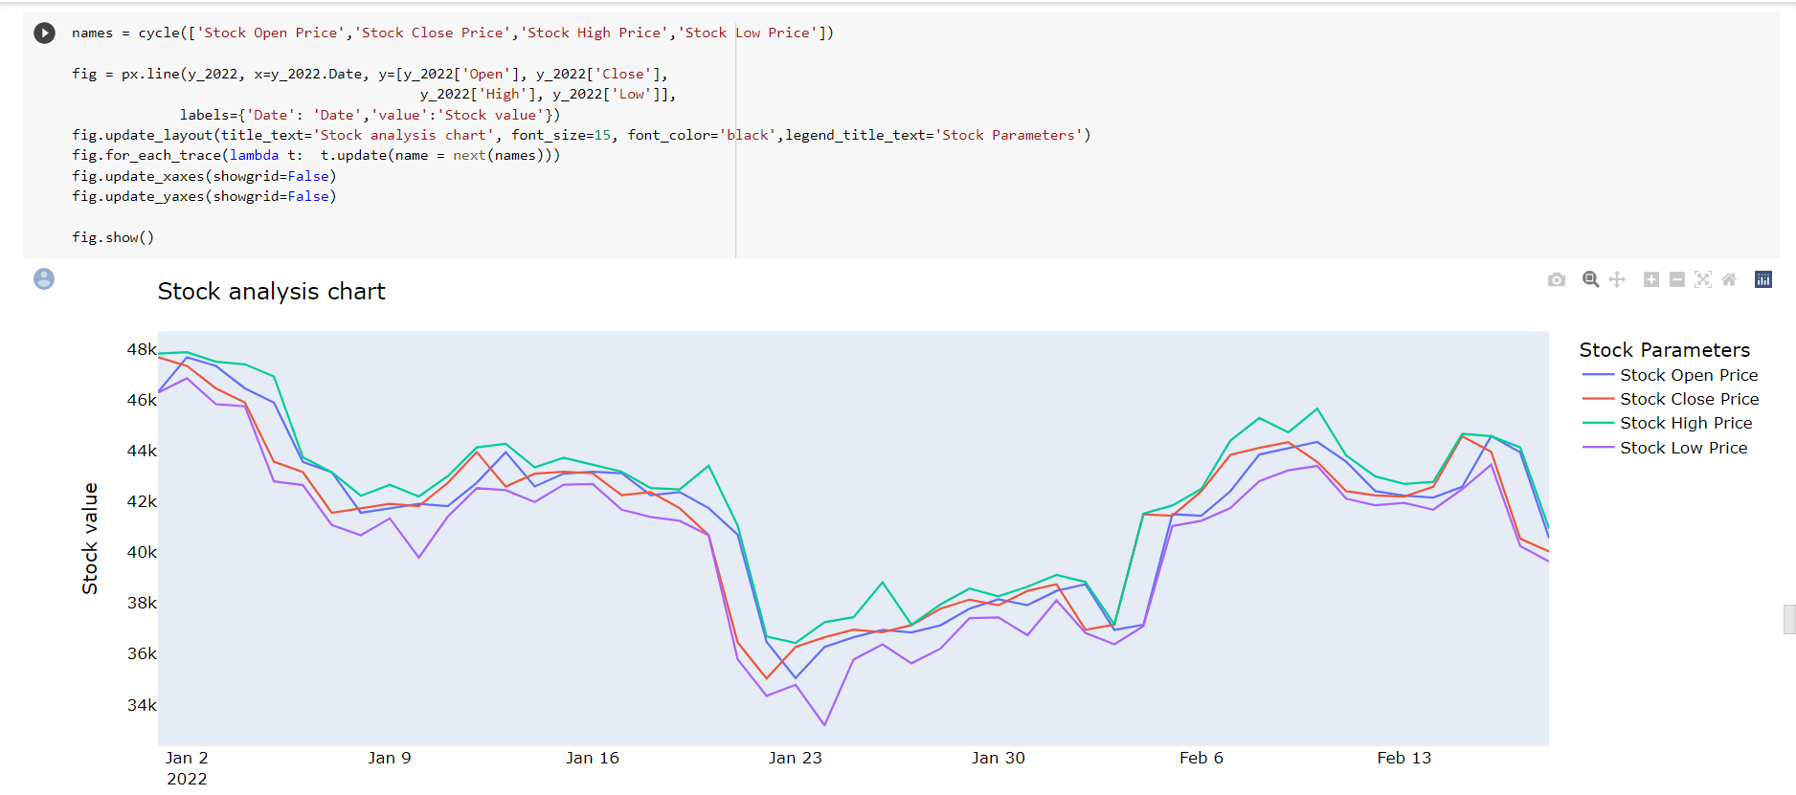

Fig 4.23:Stock analysis chart

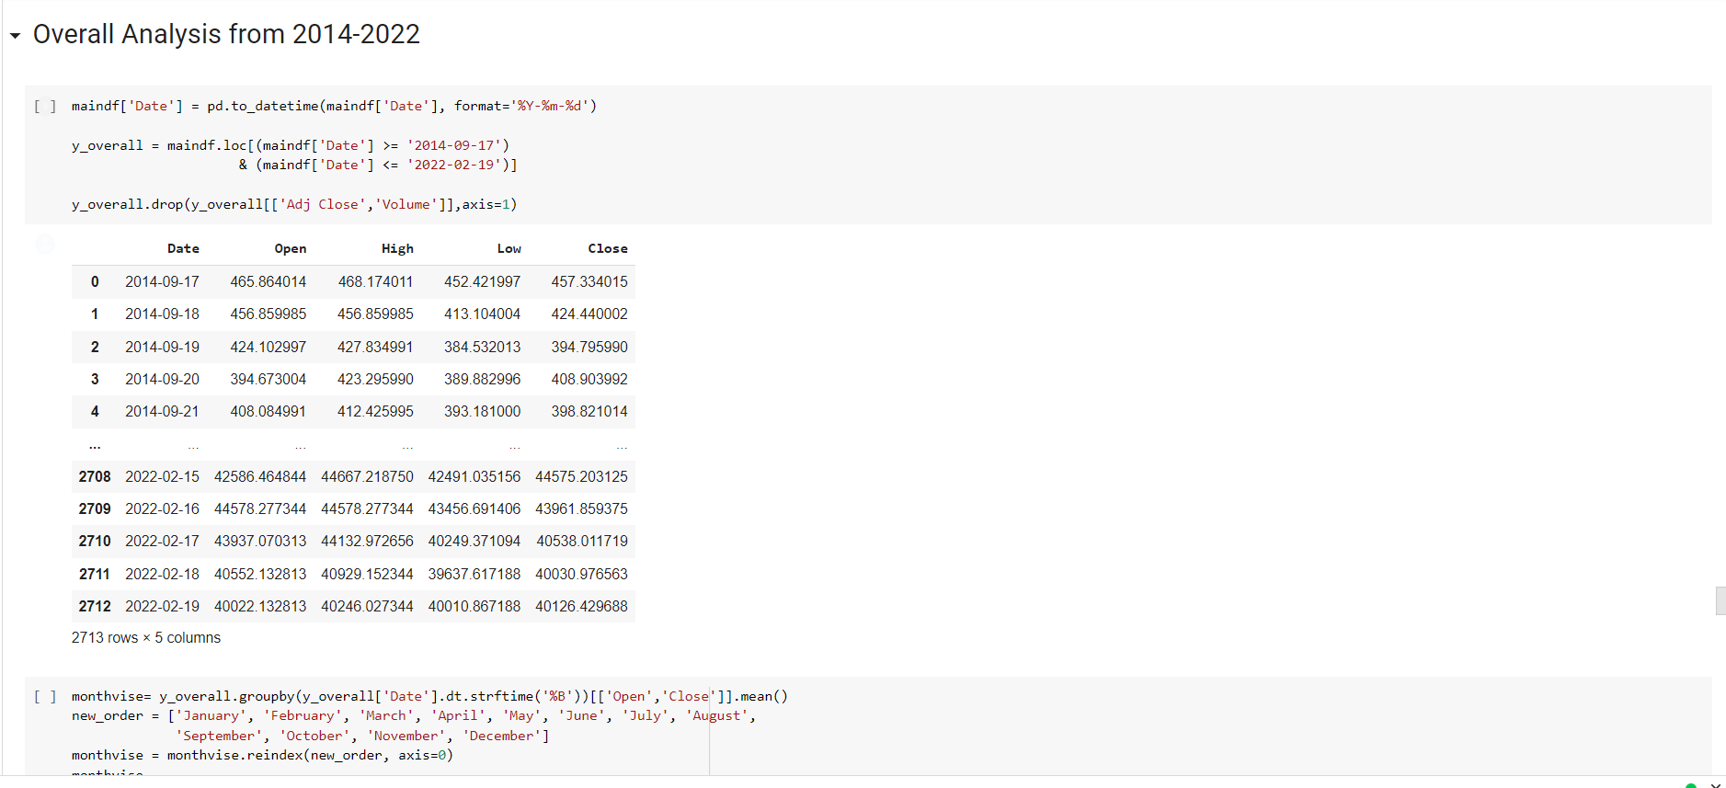

Fig 4.24: Overall Analysis

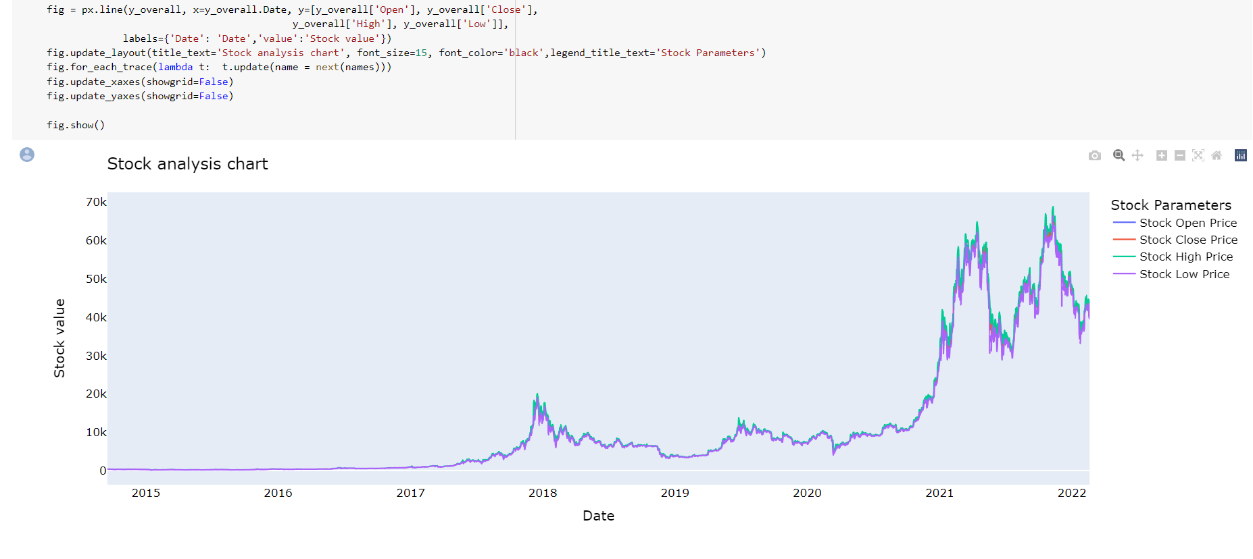

Fig 4.25: Stock Analysis of prices

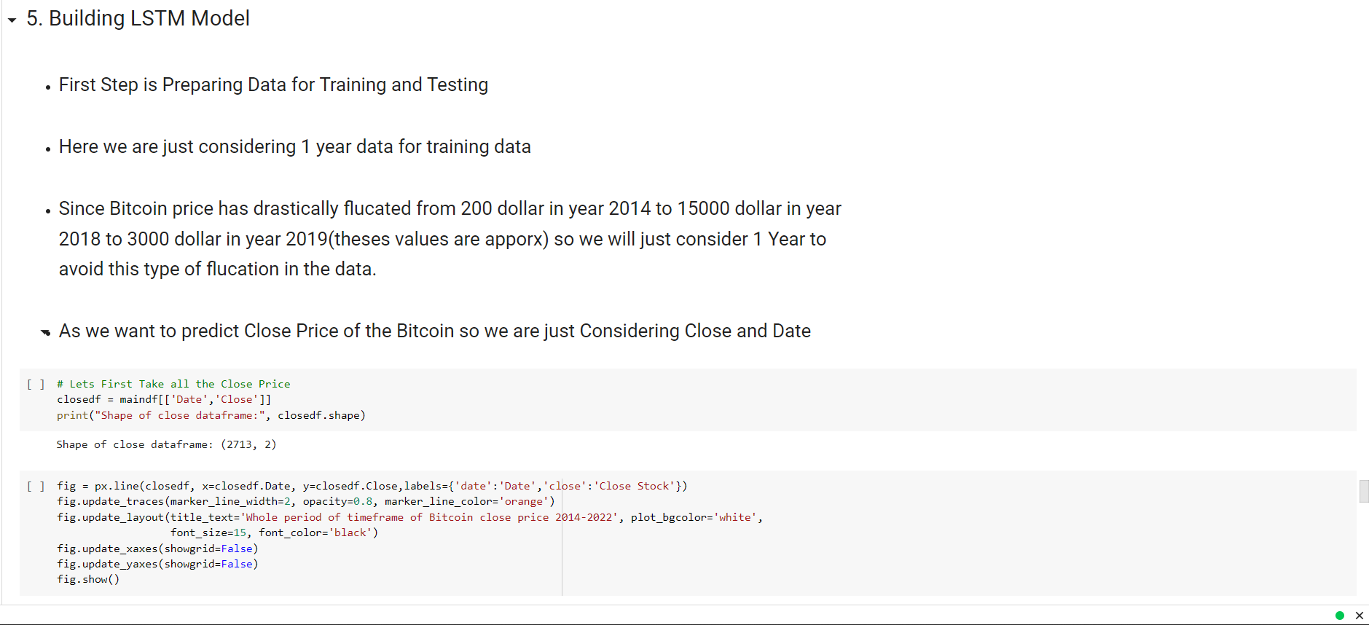

Fig 4.26 : LSTM Model

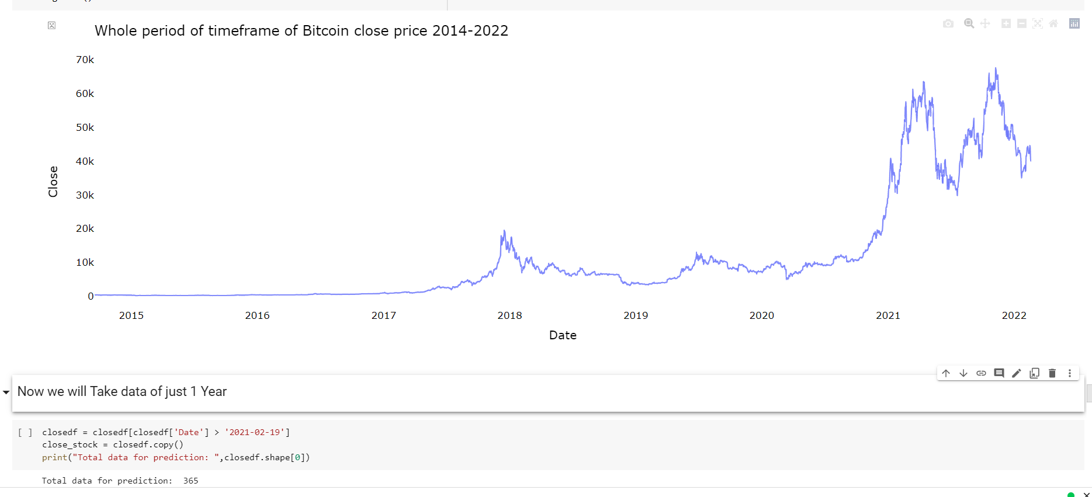

Fig 4.27: Timeframe of bitcoin price

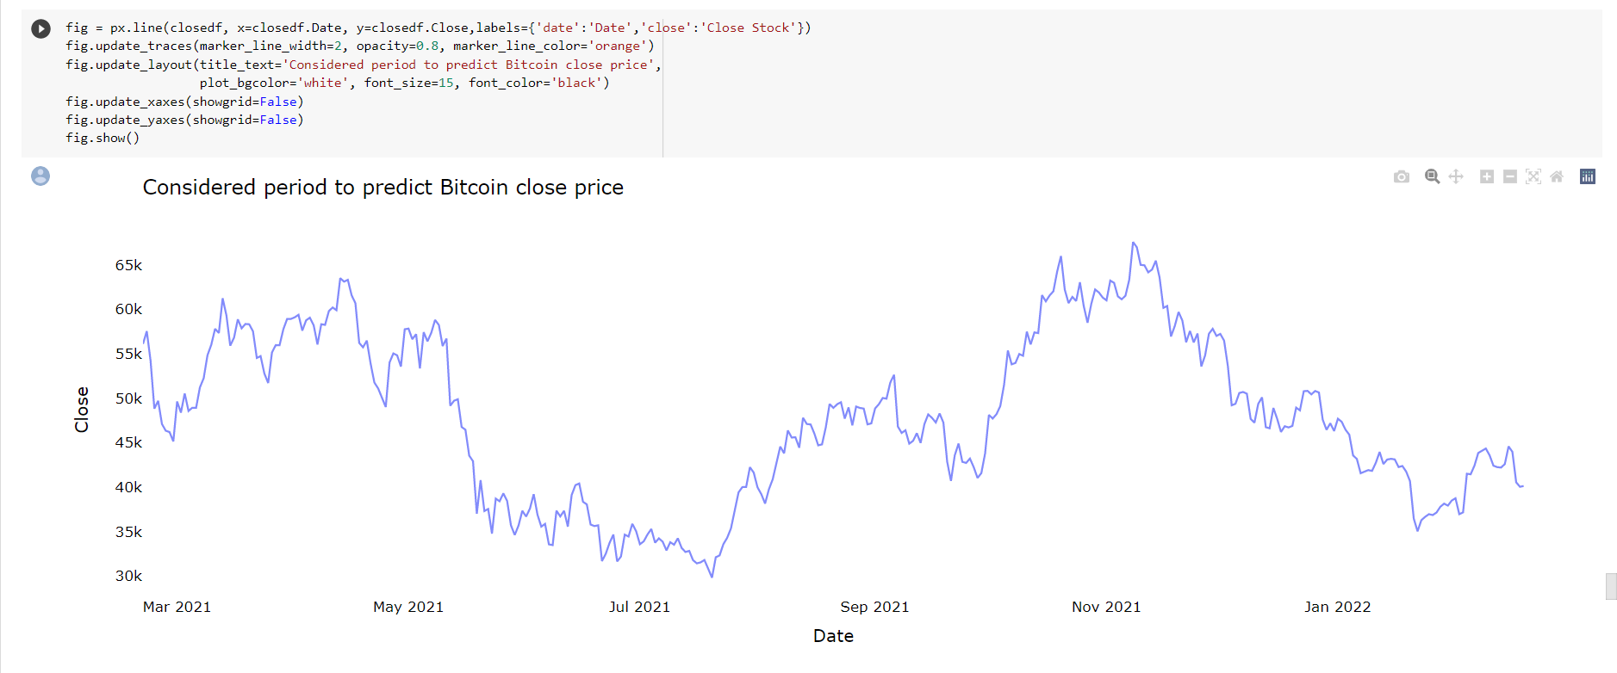

Fig 4.28: Considered period to Predict bitcoin

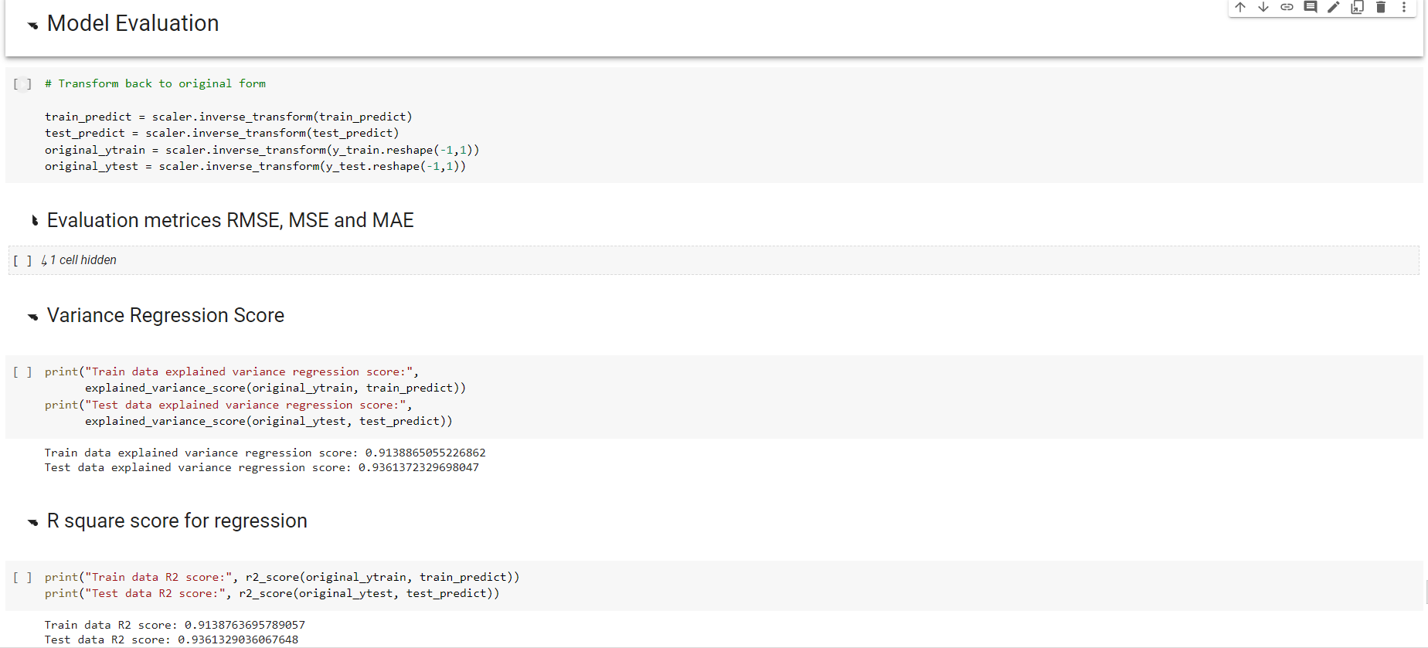

Fig 4.29: Model Evaluation

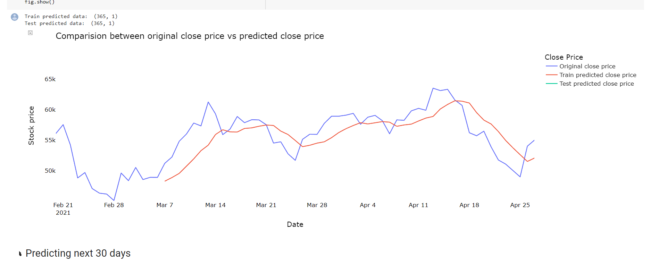

Fig 4.30: Comparison between original and predicted price

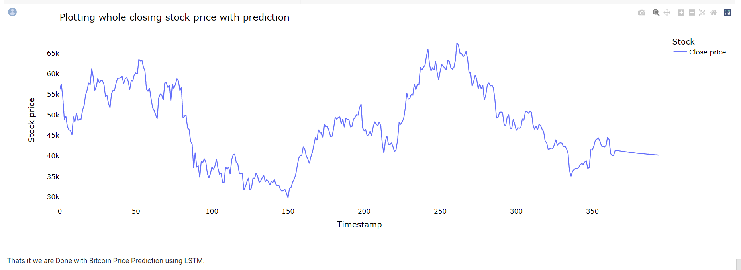

Fig 4.31: Closing Stock price with prediction

**4. Conclusion**

LSTM is an artificial recurrent neural network architecture for deep learning. Unlike standard neural networks, LSTMs have feedback connections. It can handle not just single data points but entire data ranges. A long-short-term memory (LSTM) network is a recurrent neural network capable of learning sequence dependencies in prediction problems. This is the desired behaviour in complex problem domains like machine translation, speech recognition, etc. LSTMs are a complex area of ​​deep learning. LSTMs are often referred to as sophisticated RNNs. Vanilla RNN has no cellular state. They only have hidden states, which serve as the memory of the RNN. Meanwhile, LSTM has both a cell state and a hidden state.

# **5. References**

[1] Sina E. Charandabi, Kamyar Kamyar(2021) -Prediction of Cryptocurrency Price Index Using Artificial Neural Networks, Proposed hybrid artificial neural network models to predict prices of cryptocurrency.

[2]Ahmed M. Khedr, Ifra Arif, Pravija Raj P V(2021) – Traditional statistical methods require a lot of statistical assumptions that could be unrealistic, leaving machine learning as the best technology in this field.

[3]Edwin, Lipo Wang (2017) - Described the features of Bitcoin and the following day's change in the price of Bitcoin using an Artificial Neural Network ensemble.

[4] Yeray Mezquita, Ana Belén Gil-González, Javier Prieto, and Juan Manuel Corchado (2021)-described that the solutions proposed are for detecting patterns and anomalies in cryptocurrency ecosystems.

[5] Lloyd Kasal, Mihir Shetty, Tanmay Nayak, Ramanath Pai, and Shilpa B(2022) proposed that numerous different kinds of neural networks may be utilized to analyse cryptocurrency values. The most successful of them all has been determined to be LSTM.

[6]Ahmed M. Khedr Ifra Arif Pravija Raj P V Magdi El-Bannany (2021)- proposed that traditional statistical methods, although simple to implement and interpret, require a lot of statistical assumptions

[7]Caporale, Guglielmo Maria Plastun, Alex (2018),-Cryptocurrency market Bitcoin overreaction momentum abnormal returns contrarian strategy trading robot.

[8]Al-Yahyaee KH, Mensi W(2020) -Multifractality, long-memory process, and efficiency hypothesis of six major

cryptocurrencies using the time-rolling MF-DFA approach.

[9]Magdi El-Bannany, Saadat M. Alhashmi, Meenu Sreedharan(2016) - Cryptocurrency price prediction using traditional statistical and machine-learning techniques, this type of model approach called Genetic Algorithm based Selective Neural Network Ensemble.

[10]Ujan Mukhopadhyay; Anthony Skjellum; Oluwakemi; Hambolu; Jon Oakley; Richard Brooks(2022) proposed that Cryptocurrencies require robust and secure mining algorithms. In this paper, we survey and compare and contrast current mining techniques used by major Cryptocurrencies.

[11] Carmine Ventre, Michail Basios, Leslie Kanthan, David Martinez-Rego(2022), This survey analyzes the research distribution that characterizes cryptocurrency Research and distribution among properties.

[12] Sina E. Charandabi; Kamyar Kamyar (2021), This survey paper aims to present and compare multiple research papers that employed multiple neural networks.

[13] Saeed Alzahrani; Tugrul U. Daim(2019) -Paper suggests that the main factors driving the adoption decision are the acceptance by businesses as a payment method and the fast transfer of funds.

[14]Pravija Raj, Magdi El-Bannany, Saadat M.Alhashmi, Meenu Sreedharan(2021) –Research in this field uses traditional statistical and machine-learning techniques, making it hard to predict using a statistical approach.

[15] [George S.](https://www.sciencedirect.com/science/article/pii/S037722171930075X#!)Atsalakis(2021) –Fuzzy modelling demonstrating that the closed-loop or feedback control technique can cope with uncertainties associated with the dynamic behaviour of the price of Bitcoin, and achieve positive returns.